PARTIAL LOAD BENEFITS
QUESTIONS * ANSWERS * PROCEDURES

Q If I am not full time am I eligible for benefit coverages?
A The following are part time statuses as defined by the Academic Collective Agreemen
Part time employee – your contract provides you with 6 or less hours per week
Sessional employee – your contract provides you with more than 12 hours per week
You are NOT ELIGIBLE FOR BENEFIT COVERAGES if you are one of the above statuses
Partial Load employee – your contract provides you with between
7 – 12 hours per week (inclusive).
YOU ARE ELIGIBLE TO PARTICIAPTE BENEFIT COVERAGES IF YOU ARE PARTIAL LOAD

Q How do I find out about these benefits?
A Once you have signed your partial load contract with your faculty it is
forwarded to Payroll.
- Once payroll enters your contract into the payroll system the Pension & Benefit Specialist runs bi-weekly reports to identify all part load staff.
- As you are identified on the report then an email will be sent to you by the Pension & Benefit Specialist. The subject line on the email is entitled IMPORTANT INFORMATION – Re: Partial Load benefits.
- This email will contain a memo outlining the process for enrolment as well as several attachments which will outline a description of each of the benefits, costs, waiting period and the enrolment form.
- It is important to note: The email is sent to your Sheridan College employee email address ONLY. It is your responsibility to check this email frequently for any College communications

Q What types of benefits are there?
A Extended Health Care, Dental and several life insurance coverages. A description of these coverages can be found on Appendix A that follows.
Q Am I automatically enrolled or must I fill out forms?
A If this is your FIRST partial load contract OR you if there has been a break or MORE THAN 6 MONTHS since your last partial load contract then you must fill out an enrolment form which will be included as an attachment in the email that is sent to you.

Q Are there waiting periods before I can begin to use the benefits?
A Each of the coverages has a waiting period that must be satisfied before
the coverage becomes effective. They are outlined on the chart below.

For the purposes of your group insurance benefits, you are considered as
a NEW EMPLOYEE under your first partial load contract OR if there is a break of MORE THAN 6 MONTHS BETWEEN PARTIAL LOAD CONTRACTS.

Benefit Waiting Period

Basic Life Insurance  Accidental Death &Dismemberment Insurance  Supplementary Life Insurance Employee Pay-All  Life Insurance Dependent Basic Life Insurance  Extended Health Care (including vision and  Hearing care. | First of the month following the completion of one calendar month of employment  First of the month following the completion of one calendar month of employment  First of the month following the completion of one calendar month of employment
Dental Care | First of the month following the completion of six calendar months of employment.
Critical Illness Insurance | The coverage becomes effective on the first of the month in which your application is approved by the insurance company.

Q Do I pay for all of the benefits?
A While you are actively working as a partial load employee the College pays 100% of the cost of the Extended Health coverage. For all other coverages you are responsible for 100% of the costs.
Q When do the premiums come off my pay?
A Your partial load benefit premiums are deducted from the first pay of the
month.

The costs are outlined below:
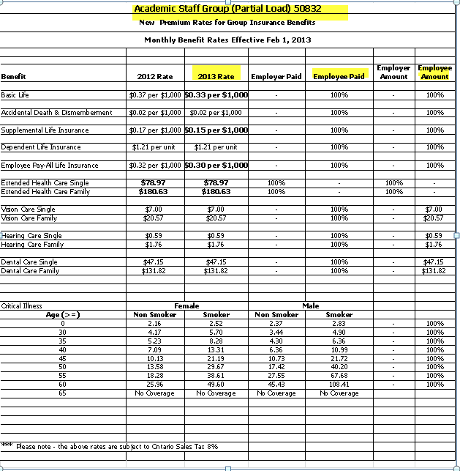

Q How do I complete the benefit form and who do I give it to?
A Instructions on how to complete the form are below. Once the form
is completed, it must be returned the Pension & Benefit Specialist
in Human Resources by the due date specified in the email and memorandum.

Before completing the enrolment form please ensure you review the Benefit At A Glance chart as well as the Premium Rate chart. These two charts will provide a description of each benefit as well as the cost.

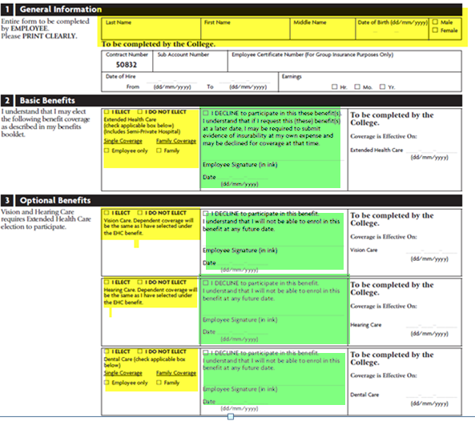

Section 1 – General Information
- The only information you must complete in this section is highlighted in yellow.
Please complete your name, date of birth and gender (female/male).

Section 2 – Basic Benefits
- In this section highlighted in yellow please tick the box for either
I elect Extended Health Care OR Do Not Elect
- If electing the coverage please indicate whether Single coverage (Employee only)
OR
Family coverage (family) is necessary.
OR
- If you do not wish the coverage then please tick I Do No Elect……then tick the
I Decline to Participate in the section that is highlighted in green then…….
Sign and date

Section 3 – Optional Benefits
- For each of the coverages in this section highlighted in yellow please indicate whether you wish to I Elect OR I Do Not Elect

- If electing any of these coverages please indicate whether Single coverage (Employee only) OR Family coverage (family) is required.
PLEASE NOTE: If you have elected the Extended HealthCare coverage then you must make the status of either Family or Single the same for the Vision and Hearing benefits.

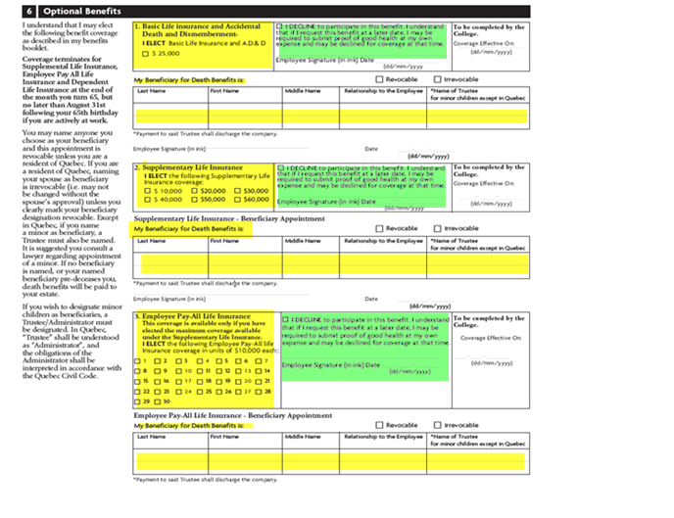
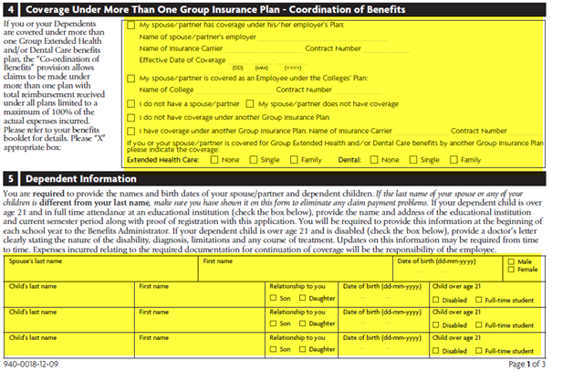
Section 4 – Coverage Under More Than One Group Insurance Plan – Coordination of Benefits
- Please indicate in the section highlighted in yellow if your spouse has benefit coverage(s).
- If so, please tick the first box and provide the information requested
i.e. Name of employer, Name of Insurance Carrier and Contract Number

Section 5 – Dependent Information
- Please indicate in this section highlighted in yellow the information requested on the dependents in your immediate family. i.e. Children and Spouse

Section 6 – Optional Benefits
- For each of the sections highlighted in yellow, please tick the amount of insurance you are electing OR
- If you do not wish the coverage then please tick I Decline to Participate in the sections for each of the benefits that is highlight in green………. then Sign and date in each section

Section 7 – Declaration
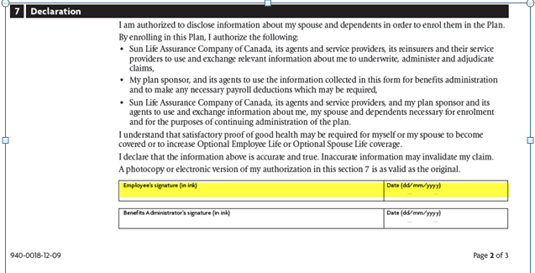
- Please sign and date on the signature line highlighted in yellow.
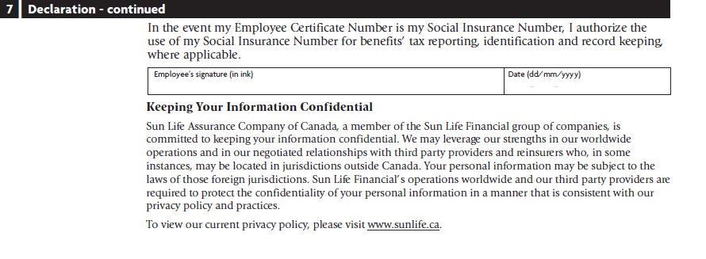
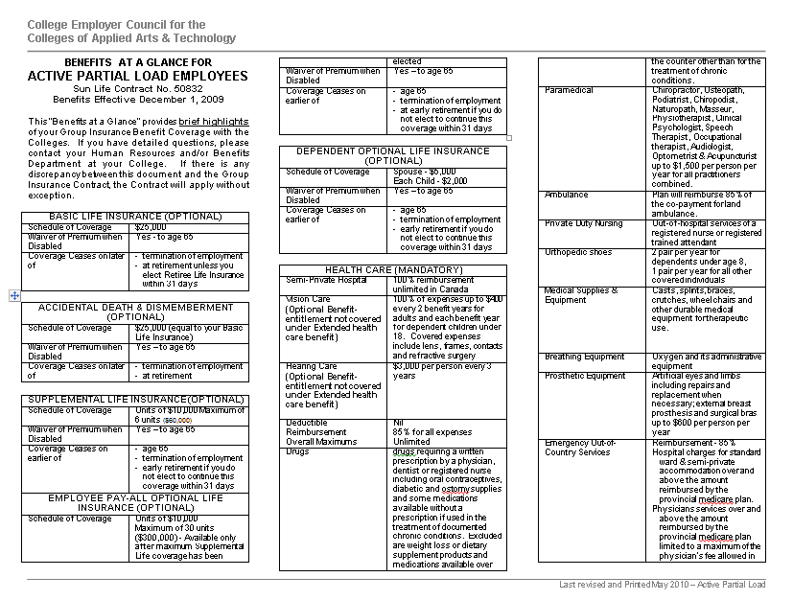
APPENDIX “A”

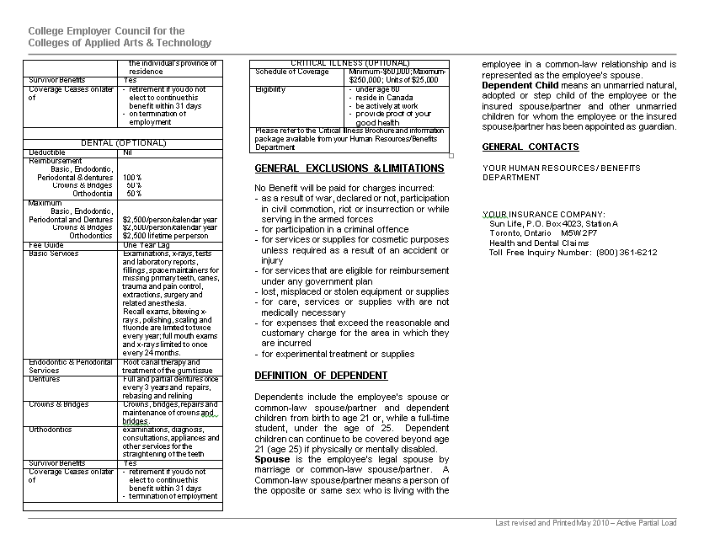
Q If I don’t complete the benefit enrolment form, what happens?
A You will be enrolled in the minimum coverage as per the
Academic Collective Agreement, which is Single Extended Heath Care,
AND will not have an option to change your benefit coverage.
- You are declining to participate in the optional benefits (vision, hearing, dental, life insurances) AND will not be able to enroll in these benefits at a future date until which time you have a break between partial load contracts of more than 6 months.
If you do not wish to be enrolled “automatically” into the Extended Health then you MUST complete the attached enrolment form declining each of the benefit coverages in each of the decline statements. Please sign and date each section as well as the declaration in Section 7 then return the form to my attention.
Q Can I add/change my benefits at any time? Can I add a dependent?
A The only change permitted is to change your benefit participation from
single to family or vice-versa in the benefits in which you are enrolled,
under the following special circumstances within 31 days of the event.
* If there is a change in your marital status.
* If you gain or lose a dependent.
Q When do my benefits end and what happens to my
benefits upon termination of my partial load contract?
A Your partial load benefits are terminated at the end of the month in which
your partial load contract terminates.
- You may also have the opportunity to “bridge” your benefits.” In order to
bridge the benefits you must arrange for the following BEFORE THE END OF YOUR CURRENT P.L. CONTRACT: It is your responsibility to contact your Pensions and Benefits Specialist before the end of your contract if your intention is to bridge your benefits.
- A written contract for a future partial load contract, or a letter/email from the Dean/Associate Dean of your school, stating their commitment to a future partial load contract
- A completed pre-authorized payment form authorizing us to make the applicable monthly deductions from your bank account.

